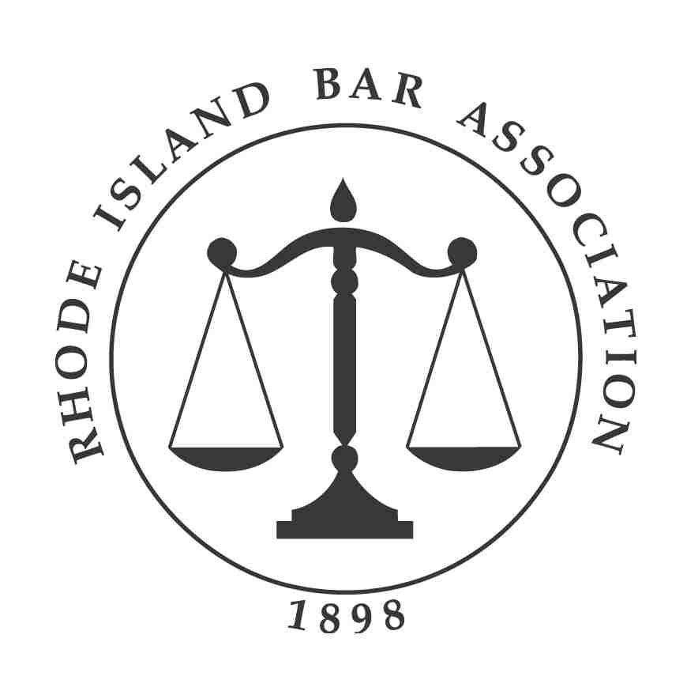

Rhode Island Bar Journal

Editorial Statement

The Rhode Island Bar Journal is the Rhode Island Bar Association’s official magazine for Rhode Island attorneys, judges and others interested in Rhode Island law. The Bar Journal is a paid subscription magazine published bi-monthly, six times annually and sent to, among others, all practicing attorneys and sitting judges, in Rhode Island. This constitutes an audience of over 6,300 individuals. Covering issues of relevance and providing updates on events, programs and meetings, the Rhode Island Bar Journal is a magazine that is read on arrival and, most often, kept for future reference. The Bar Journal publishes scholarly discourses, commentary on the law and Bar activities, and articles on the administration of justice. While the Journal is a serious magazine, our articles are not dull or somber. We strive to publish a topical, thought-provoking magazine that addresses issues of interest to significant segments of the Bar. We aim to publish a magazine that is read, quoted and retained. The Bar Journal encourages the free expression of ideas by Rhode Island Bar members. The Bar Journal assumes no responsibility for opinions, statements and facts in signed articles, except to the extent that, by publication, the subject matter merits attention. The opinions expressed in editorials are not the official view of the Rhode Island Bar Association. Letters to the Editor are welcome.

Article Selection Criteria

- The Rhode Island Bar Journal gives primary preference to original articles, written expressly for first publication in the Bar Journal, by members of the Rhode Island Bar Association. The Bar Journal does not accept unsolicited articles from individuals who are not members of the Rhode Island Bar Association. Articles previously appearing in other publications are not accepted.
- All submitted articles are subject to the Journal’s Editor’s approval, and they reserve the right to edit or reject any articles and article titles submitted for publication.
- Selection for publication is based on the article’s relevance to our readers, determined by content and timeliness. Articles appealing to the widest range of interests are particularly appreciated. However, commentaries dealing with more specific areas of law are given equally serious consideration.
- Preferred format includes: a clearly presented statement of purpose and/or thesis in the introduction; supporting evidence or arguments in the body; and a summary conclusion.
- Citations conform to the Uniform System of Citation
- Maximum article size is approximately 3,500 words. However, shorter articles are preferred.
- While authors may be asked to edit articles themselves, the Editor reserves the right to edit pieces for legal size, presentation and grammar.
- Articles are accepted for review on a rolling basis. Meeting the criteria noted above does not guarantee publication. Articles are selected and published at the discretion of the Editor.
- Submissions are preferred in a Microsoft Word format emailed as an attachment or on disc. Hard copy is acceptable, but not recommended.
- Authors are asked to include an identification of their current legal position and a photograph, (headshot) preferably in a jpg file of, at least, 350 d.p.i., with their article submission.

Rhode Island Bar Journal Submission Deadlines and Publication Considerations

Due to production schedules, all submissions for Rhode Island Bar Journal publication consideration must be received, in a Word format, by email, by the Journal’s Editor Kathleen Bridge at kbridge@ribar.com no later than the first of two months prior to the publication date. For example: November 1st for the January/February issue; January 1st for the March/April issue and so on. The Journal is generally able to accommodate short notices of one-page or less, maximum of 750 words, within that time frame. Submitting lengthier piece or articles for publication consideration does not guarantee acceptance or placement in the next issue, as there is often a queue of previously-accepted articles awaiting placement. However, if a piece is particularly time sensitive, the Journal Editor will work to accommodate the piece into an appropriate issue.

Direct inquiries and send articles and author photographs for publication consideration to:
Rhode Island Bar Journal Editor Kathleen M. Bridge
email: kbridge@ribar.com
telephone: 401-421-5740

Material published in the Rhode Island Bar Journal remains the property of the Journal, and the author consents to the rights of the Rhode Island Bar Journal to copyright the work.

