`` 56 Pine Street, Suite 400 50 Washington Square

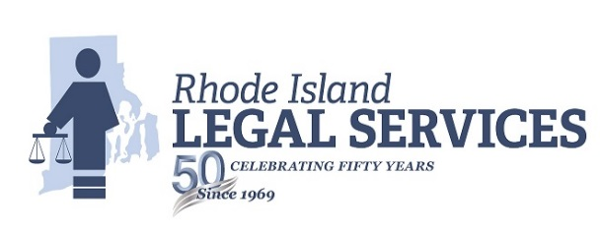

Providence, RI 02903 Newport, RI 02840

(401) 274-2652 (401) 846-2264 (800) 662-5034 (800) 637-4529

FAX (401) 272-5335 FAX (401) 848-0383

______________________________________________________________________________________________

RESPONSIBLE PARENT PROJECT

STAFF ATTORNEY

PROVIDENCE OFFICE

Rhode Island Legal Services, Inc., a statewide program with its principal office in Providence, seeks a staff attorney to work in the Responsible Parent Project in the Providence office.

Responsibilities include: representation of low income persons in family law matters including child support; frequent court appearances; participate in educational forums and with community groups related to family law; develop familiarity with other areas of poverty law that are relevant to family law practice.

Qualifications: Candidates admitted to Rhode Island Bar or Bar of any other state preferred; must be willing to take the next Rhode Island Bar exam. Spanish speaking ability preferred.

Closing Date: Open Until Filled

Salary: Commensurate with relative legal experience in accordance with Union Contract. Excellent fringe benefits.

Send resume to:

Nicola Carrara, Executive Assistant

Rhode Island Legal Services, Inc.

56 Pine Street Suite 400

Providence, Rhode Island 02903

Rhode Island Legal Services, Inc., is and Equal Opportunity, Handicapped Accessible Employer. Women, minorities, the elderly, and persons with disabilities are encouraged to apply.

Date of Posting: September 17, 2018